
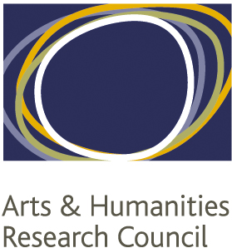
NORTH WEST CONSORTIUM
DOCTORAL TRAINING PARTNERSHIP
Research Networks Fund
(2024)

The NWCDTP offer support for student-run research networks. The aims of the scheme are:
- To promote the closer integration of our student cohort by means of the creation of research groups working across pathway boundaries.
- To develop students’ skills in interdisciplinary and multidisciplinary working.
- To develop students’ capacity to become research leaders.
We invite bids for sums up to £2K for sustainable networks. Small bids (in the region of £500) are welcome for pilot initiatives, such as reading groups that might develop into fully-fledged networks.

Eligible Applicants and Network Members:
Named applicants must be NWCDTP students, but we would expect network membership to be open to all interested arts and humanities PhD students within the Consortium. Networks that have a national or international membership are also encouraged, within the limits of the available funding.

Applications must include collaboration with students from at least two different institutions. Please visit our website for students’ profiles or contact the NWCDTP (nwcdtp@manchester.ac.uk) to obtain contact details of DTP students in your area.

Eligible Networks must:
- Actively involve PhD students from at least three different subject areas.
- Actively involve PhD students from at least two NWCDTP Institutions.
- Have a clear intellectual focus that draws on interdisciplinary or multidisciplinary perspectives. This could be, for example, a shared interest in a particular region of the world, or in the application of a particular body of theory, or in the use of a particular set of research methods. This is an indicative list and is not intended to be prescriptive.
- Generate an output or legacy of some kind: publications, podcasts, blog posts etc. as appropriate.

Eligible Costs (this list is indicative rather than exhaustive)
- Travel for network members (it is a requirement that the costs of NWCDTP students should be covered, but subject to budgetary constraints we can also pay the costs of other network members within the region)
- Catering
- Costs of visiting speakers (travel, accommodation, subsistence) from outside the DTP. Fees may be paid where this is in accordance with professional norms (e.g. we would not normally pay a fee to a salaried academic, but a freelance practitioner might reasonably require a fee).

Ineligible Costs
- Room hire within one of the member HEIs.
- Staff costs for academic staff within the DTP.

How to apply
Application can be found on our website. There are no deadlines. We will aim to respond to your application submission within 2-3 weeks.

